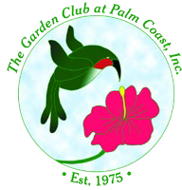
The Garden Club at Palm Coast, Inc.
P.O. Box 352153 Palm Coast, FL 32135-2153

www.GardenClubAtPalmCoast.org facebook.com/Gardenclubatpalmcoast/ info@GardenClubAtPalmCoast.org

