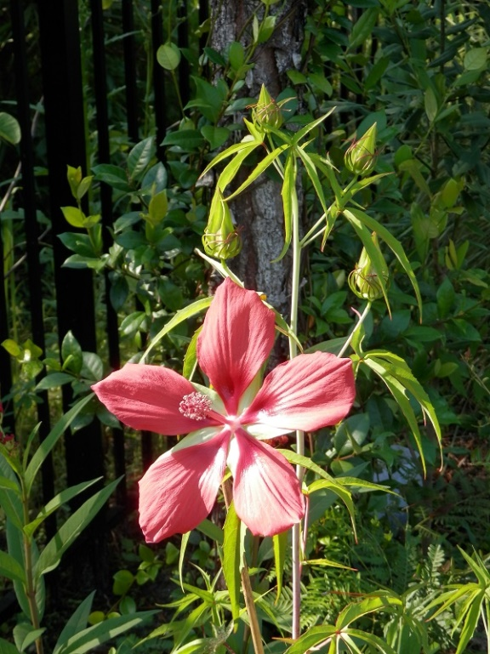
Hibiscus coccineus
“Texas Star”, “Swamp Hibiscus”
Height: 6 – 8 ft
Spread: 4 – 6 ft
Growth Pace: Fast
Light: Sun – Part shade
Hardiness: USDA Zone 6-11
Moisture: Average - wet
Maintenance: Low
Bloom Time: Spring - Summer
Flower Color: Red
Type: Perennial, native
Attracts: Bees, Butterflies

Plant Info template – card 4 x 6“. Word Page 6 x 8 with 1” margins
Grid lines show you the area of the card: View – Gridlines - tick on
Insert photo of approx. shown size.
Right click photo and set Wrap Text to Square
Before printing turn off grid: View – Gridlines - tick off
Only print page 1.
Sources of plant info:
https://davesgarden.com/guides/pf/go/185258/ search by name
http://www.onlineplantguide.com/index.aspx
https://www.bhg.com/bin/plants/?name=denver+daisy&zipZone=
https://garden.org/plants/
https://plantinfo.umn.edu/
http://florida.plantatlas.usf.edu/
https://ffl.ifas.ufl.edu/plants
http://www.floridayards.org

