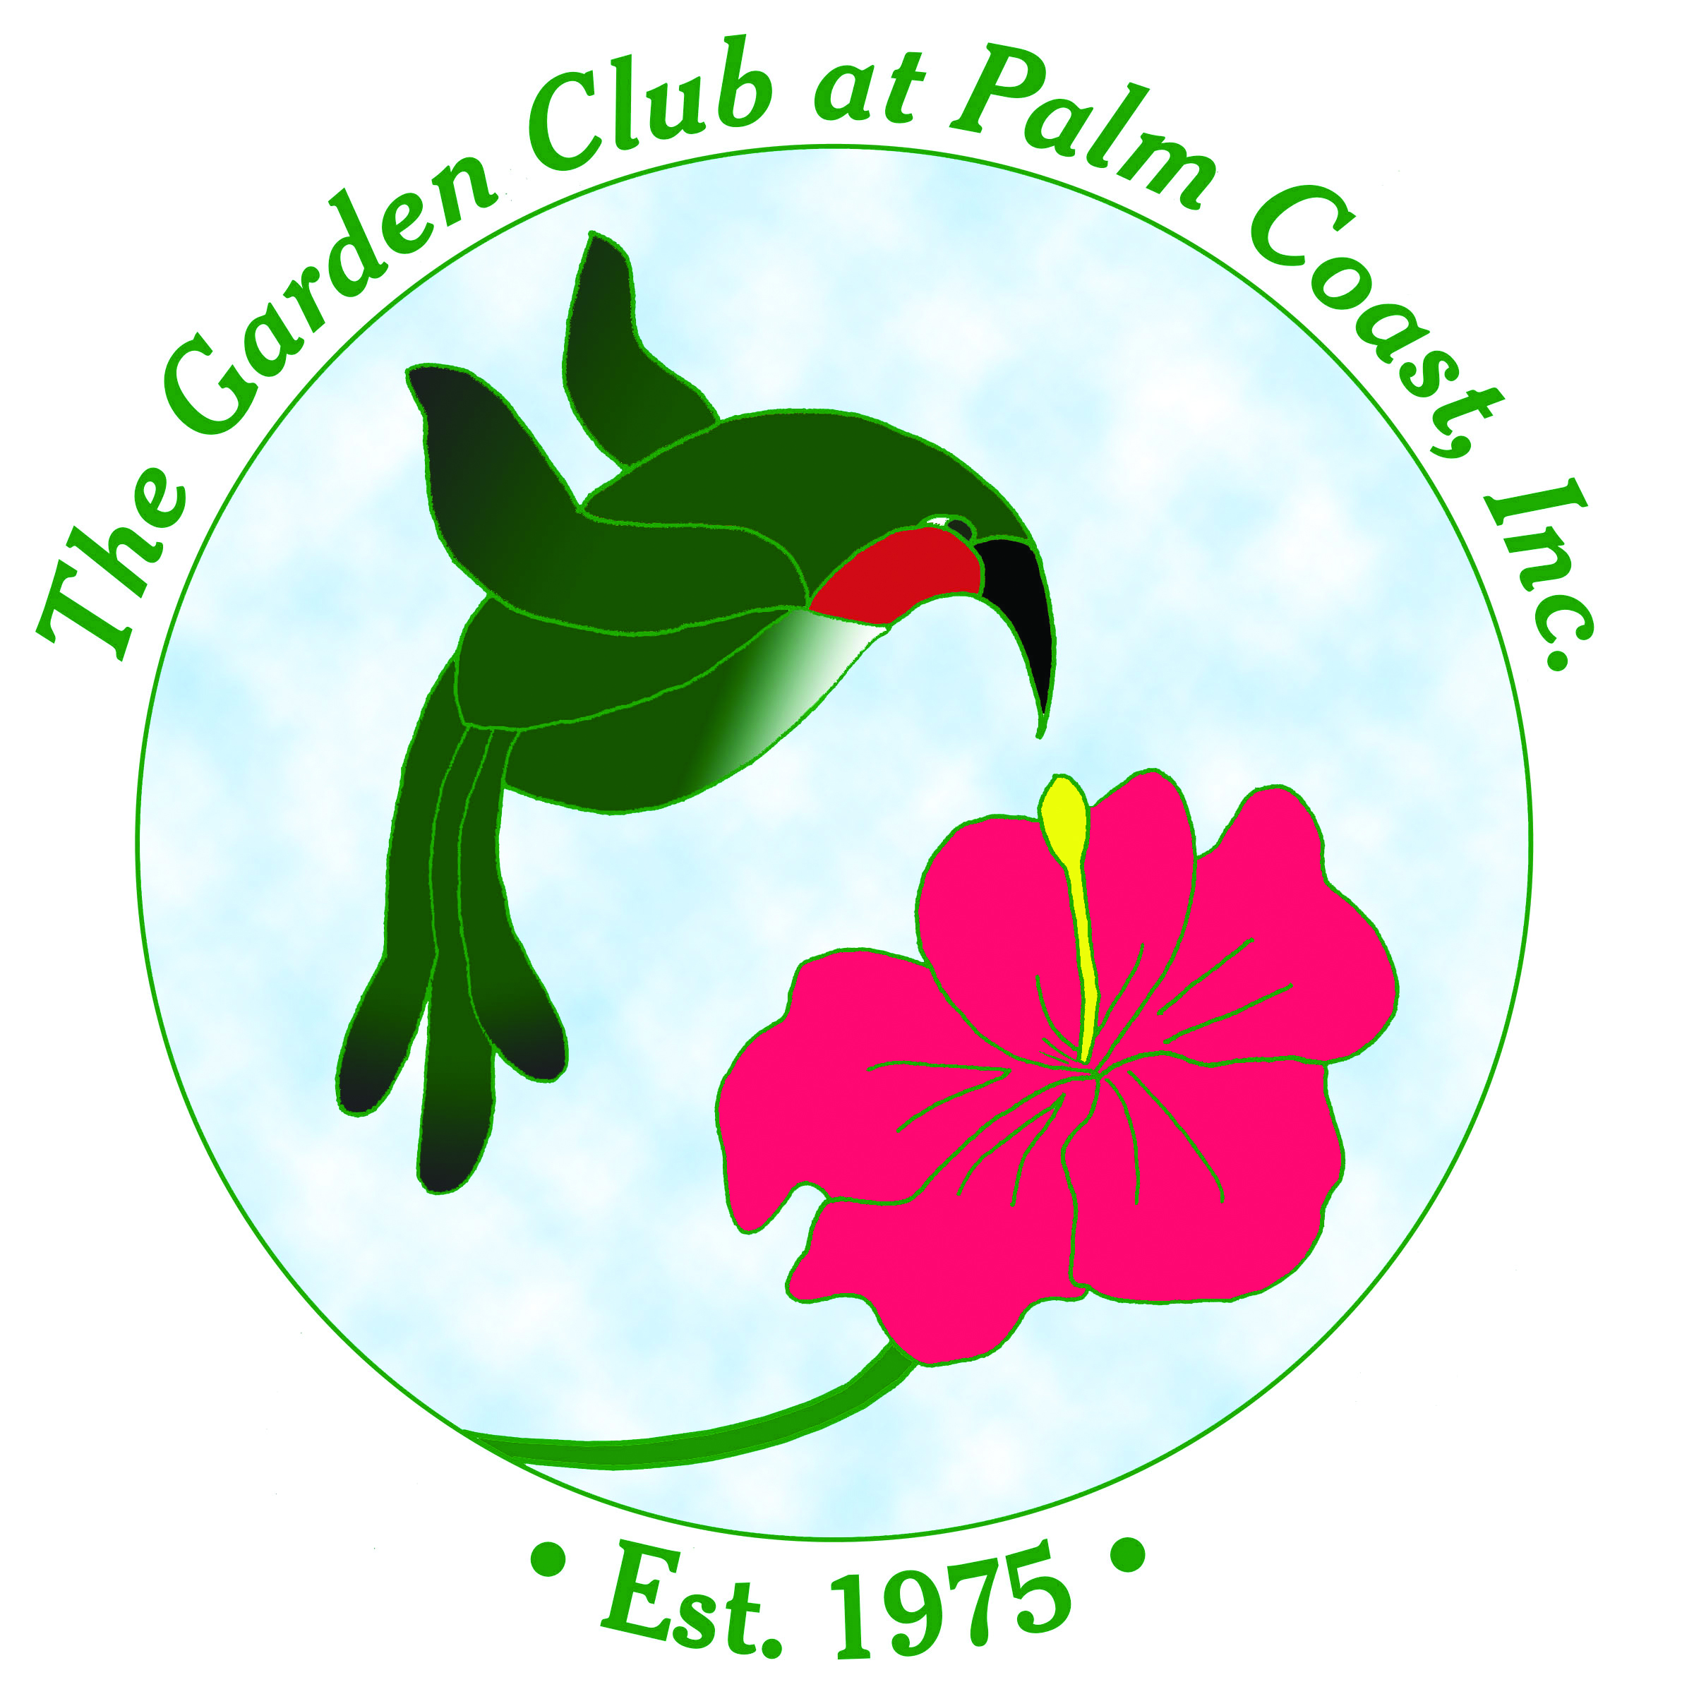
Butterfly Plants for Flagler County
Compiled by The Propagation Guild of
The Garden Club at Palm Coast

Botanical Name | Common Name | Use | Butterfly
Acer negundo (N) | Box-elder | Larval
Acer rubrum (N) | Red Maple | Larval | Cecropia, Imperial, Polyphemus, Rosy
Achillea millefolium (N) | Common Yarrow | Larval/Nectar | Painted Lady
Aesculus pavia (N) | Red Buckeye | Nectar
Agalinis fasciculata (N) | Beach False Foxglove
Ageratum spp. | Ageratum | Nectar
Alcea rosea | Hollyhock
Aletris lutea (N) | Yellow Colic-root
Allium tuberosum | Garlic chives
Amorpha fruticosa | False Indigo Bush | Larval/Nectar | Southern Dogface, Gray Hairstreak, Silver-spotted Skipper
Andropogon virginicus (N) | Broomsedge Bluestem | Larval | Zabulon Skipper
Antigonon leptopus | Coral Vine
Aralia spinosa (N) | Devil’s Walking Stick
Argemone albiflora (N) | White Prickly Poppy
Aristolochia tomentosa (N) | Pipevine | Larval | Pipevine & Gold Rim Swallowtail
Aristolochia elegans | Calico Flower | Larval | Gold Rim Swallowtail
Asclepias humistrata (N) | Sandhill Milkweed | Larval | Monarch, Queen
Asclepias incarnata (N) | Swamp Milkweed | Larval | Monarch, Queen, Soldier
Asclepias lanceolata (N) | Red Milkweed | Larval | Monarch, Queen
Asclepias perennis (N) | White Swamp Milkweed | Larval | Monarch, Queen, Soldier
Asclepias tuberosa (N) | Butterfly Weed | Larval/Nectar | Monarch, Queen, Solider
Asclepias verticillata (N) | Whorl-leaf Milkweed | Larval | Monarch
Asimina incana (N) | Flag Pawpaw | Larval | Zebra Swallowtail, Pawpaw Sphinx
Asimina obovata (N) | Scrub Pawpaw | Larval | Zebra Swallowtail, Pawpaw Sphinx
Asimina pygmea (N) | Dwarf Pawpaw | Larval | Zebra Swallowtail, Pawpaw Sphinx
Asimina reticulata (N) | Netted Pawpaw | Larval | Zebra Swallowtail, Pawpaw Sphinx
Asimina triloba (N) | Common Pawpaw | Nectar | Zebra Swallowtail
Aster caroliniensis (N) | Climbing Aster | Larval/Nectar | American Painted Lady, Pearl Crescent
Aster dumosus (N) | Wood Aster | Larval/Nectar
Aster elliottii (N) | Elliott’s Aster | Nectar
Baccharis halmifolia (N) | Salt Bush
Bacopa caroliniana (N) | Blue Waterhyssop | Larval | White Peacock
Bacopa monnieri (N) | Water Hyssop | Larval | White Peacock
Balduina angustifolia (N) | Coastalplain Honeycombhead | Nectar | Gulf Fritillary
Batis maritima (N) | Saltwort | Larval | Southern White, Eastern Pigmy Blue
Befaria racemosa (N) | Tarflower | Nectar
Bidens spp. (N) | Beggar Ticks/Spanish Needle | Nectar
Blechnum serrulatum (N) | Swamp Fern | Larval | Malachite, White Peacock
Boehmeria cylindrica (N) | False Nettle | Larval | Red Admiral, Question Mark, Eastern Comma
Borage officinalis | Borage | Nectar
Borrichia frutescens (N) | Sea-oxeye Daisy | Nectar
Brassica spp. | Cabbage | Larval | Cabbage, Checkered White
Buddleia officinalis | Butterfly Bush | Nectar
Callicarpa americana (N) | Beauty Berry
Cladium jamaicense (N) | Saw-grass | Larval | Palatka Skipper
Campsis radicans (N) | Trumpet Creeper | Larval | Plebeian Sphnix
Canna flaccida (N) | Yellow Canna | Larval | Canna Skipper, Brazilian Skipper
Carphephorus corymbosus (N) | FL Paintbrush | Nectar
Carphephorus odoratissimus | Vanilla Plant | Nectar
Carphephorus paniculatus (N) | Deer Tongue | Nectar
Carphephorus subtropicanus (N) | Pineland Purple | Nectar
Carpinus caroliniana (N) | Hornbeam | Larval | Tiger Swallowtail, Striped Hairstreak, Red-spotted purple or White Admiral
Carya glabra (N) | Pignut Hickory | Larval | Banded Hairstreaks, Luna, Polyphemus, Royal Walnut Moth
Cassia alata | Candlestick Cassia | Larval | Cloudless Sulphur, Sleepy Orange, Orange-Barred Sulphur
Cassia bahamensis | Chapman’s Senna | Larval | Cloudless Giant Sulphur, other sulphurs
Cassia fasciculata | Patridge Pea | Larval | Cloudless Sulphur
Celtis laevigata (N) | Hackberry | Larval | Hackberry Emperor, American Snout, Tawny Emperor, Question Mark
Ceonanthus americanus (N) | New Jersey Tea | Nectar
Chamaecrista fasciculata (N) | Patridge-pea | Larval | Cloudless Sulphur, Gray Hairstreak, Orange Sulphur, Sleepy Orange, Little Yellow, Ceraunus Blue
Chiococa alba (N) | Snowberry | Larval | Miami Blue, Snowberry Clearwing
Cephalanthus occidentalis (N) | Buttonbush | Larval/Nectar | Titan Sphinx, Hydrangea Sphinx
Cercis canadensis (N) | Redbud | Larval
Cestrum nocturnum | Night Blooming Jasmine
Chamaecrista fasciculata (N) | Partridge Pea | Larval | Cloudless Giant Sulphur
Chionanthus virginicus (N) | White Fringe Tree
Chrysanthemum sp. | Shasta Daisy | Nectar
Cirsium horridulum (N) | Purple Thistle | Larval | Little Metalmark, Painted Lady
Citharexylum spinosum (N) | Fiddlewood | Nectar
Citrus spp. | Citrus | Larval | Giant Swallowtail
Cladium jamaicense (N) | Saw-grass
Clerodendrum bungei | Rose Glory Bower
Clerodendrum splendens | Flaming Glory Bower
Coccoloba uvifera | Sea Grape
Conoclinium coelestinum (N) | Mistflower Ageratum | Nectar
Coreopsis spp. (N) | Tickseed | Nectar
Coriandrum sativum | Coriander
Cornus florida (N) | Flowering Dogwood | Larval | Spring Azure Blue
Cornus foemina (N) | Swamp Dogwood | Larval | Spring Azure
Cosmos spp. | Cosmos
Cratageus flava (N) | Summer Haw | Larval | Striped Hairstreak
Ctenium aromaticum (N) | Toothache Grass | Larval | Arogos Skipper
Cuphea hyssopifolia | False Heather | Nectar
Cuphea ignea | Cigar Plant
Dalea spp. (N) | Dalea | Larval | Eastern Dogface
Daucus carota | Queen Anne’s Lace | Larval | Black Swallowtail
Dianthus sp. | Sweet William | Nectar
Distichlis spicata (N) | Saltgrass | Larval | Obscure & Saltmarsh Skipper
Duranta erecta | Golden Dewdrop
Dyschoriste oblongifolia (N) | Twinflower | Larval/Nectar | Common Buckeye
Echinacea purpurea (N) | Purple Coneflower | Nectar
Elephantopus elatus (N) | Elephant’s Foot | Nectar
Eragrostis elliottii (N) | Elliott’s Lovegrass | Larval
Eragrostis spectabilis (N) | Purple Lovegrass | Larval
Eryngium aquaticum (N) | Snakeroot - Powder Blue/Corn | Nectar | Eastern Black Swallowtail
Ernygium yuccifolium (N) | Button Snakeroot | Larval | Eastern Black Swallowtail
Erythrina herbacea (N) | Coral Bean | Nectar
Eupatorium coelestinum | Mistflower | Nectar
Eupatorium rotundifolium (N) | Roundleaf thoroughwort/False Harhound | Nectar
Foeniculum sp. | Fennel | Larval | Eastern Black Swallowtail
Fraxinus caroliniana | Pop Ash | Larval | Eastern Tiger Swallowtail, Mourning Cloak, Viceroy
Gaillardia pulchella (N) | Blanket Flower | Nectar
Gamolepis chrysanthemoides | African Bush Daisy
Garberia heterophylla (N) | Garberia | Nectar
Gelsemium sempervirens (N) | Carolina/Yellow Jasmine | Nectar
Glandularia tampensis (N) | Tampa Verbena | Nectar
Gomphrena globosa | Globe Amaranth
Hamelia patens (N) | Firebush | Nectar
Hedychium coronarium | White Ginger Lily
Helianthus angustifolius (N) | Sunflower - Narrow Leaf | Nectar
Helianthus debilis (N) | Dune Daisy/Beach Sunflower | Nectar
Helianthus radula (N) | Sunflower - Rayless | Nectar
Helichrysum sp. | Strawflower | Nectar
Heliotropium arborescens | Common Heliotrope
Hibiscus coccinea (N) | Scarlet Hibiscus | Nectar
Hypericum sp.(N) | St. John’s-wort
Ilex cassine (N) | Dahoon Holly | Larval | Woodland Elfin
Ilex glabra (N) | Gallberry
Illicium parviflorum (N) | Anise - Yellow | Nectar
Ipomoea imperati (N) | Beach Morning Glory
Ipomoea pes-caprae subsp. brasiliensis (N) | Railroad Vine
Ipomopsis rubra (N) | Standing Cypress/Flameflower | Nectar
Itea virginica (N) | Virginia Sweetspire/Willow | Nectar
Jatropha integerrima | Spicy Jatropha
Juniperus silicicola | Red Cedar | Larval | Cedar Hairstreak
Justicia brangegeana | Shrimp plant
Lantana camara | Lantana | Nectar
Lantana depressa/involcrata (N) | Lantana - Florida | Nectar
Leonotus leonurus | Lion’s Ear
Leucanthemum vulgare | Oxeye Daisy
Liatris gracilis (N) | Blazing Star/Gay Feather | Nectar
Liatris spicata (N) | Blazing Star/Gay Feather | Nectar | Buckeye
Licania michauxii (N) | Gopher-apple
Lilium longiflorum | Easter Lily
Linaria canadensis (N) | Canadian Toadflax | Larval
Lindera benzoin (N) | Spicebush | Larval | Spicebush Swallowtail
Liriodendron tulipifera (N) | Tulip Poplar | Larval | Tiger Swallowtail
Lobelia cardinalis (N) | Cardinal Flower | Nectar
Lobelia puberula | Purple Lobelia | Nectar
Lonicera sempervirens (N) | Coral Honeysuckle | Larval/Nectar | Spring Azure, Snowberry Clearwing
Lycium carolinianum (N) | Christmasberry | Nectar | Great Southern White, Gulf Fritillary
Lyonia ferruginea (N) | Rusty Lyonia | Nectar
Lyonia lucida (N) | Shiny Lyonia/Fetterbush | Nectar
Magnolia virginiana (N) | Sweet Bay | Larval | Laurel Swallowtail
Malva spp. | Mallow | Larval | Grey Hairstreak
Mentha sp. | Mint | Nectar
Mimosa quadrivalvis var. floridana(N) | FL Sensitive Brier | Larval | Reakit’s Blue
Mimosa strigillosa (N) | Sunshine Mimosa
Monarda punctata (N) | Dotted Horsemint | Nectar
Morella cerifera (N) | Wax Myrtle | Larval | Banded Hairstreak, Red-banded Hairstreak
Morus rubra (N) | Red Mulberry | Larval | Question Mark, Red Admiral
Muhlenbergia capillaris (N) | Muhly Grasss | Larval
Myrcia cerifera (N) | Wax Myrtle | Larval | Red Banded Hairstreak
Myrcianthes fragrans (N) | Simpson’s Stopper | Nectar
Nepeta musinii | Catmint | Nectar
Oenothera laciniata(N) | Cutleaf Evening Primrose
Panicum virgatum (N) | Switchgrass
Passiflora incarnata (N) | Passion Flower | Larval/Nectar | Gulf & Variegated Fritillary, Zebra Longwing
Passiflora suberosa (N) | Corky Passion Flower | Larval | Gulf Fritillary, Julia & Zebra Heliconian
Penstemon multiflorus (N) | Manyflower Beardtongue | Larval | Baltimore Checkerspot
Pentas lanceolata | Penta | Nectar
Persea borbonia (N) | FL Red Bay | Larval | Palamedes and Spicebush Swallowtail
Persea palustris (N) | Swamp Red Bay | Larval | Spicebush, Tiger, and Palamedes Swallowtails
Petroselimum sp. | Parsley | Larval | Eastern Black Swallowtail
Phlox drummondii | Phlox | Nectar
Phoradendron scrotinum | Mistletoe | Larval | Giant Blue Hairstreak
Phyla nodiflora (N) | Frogfruit | Larval/Nectar | Phaon Crescent, White Peacock, Common Buckeye, Hairstreaks
Piloblephis rigida (N) | Pennyroyal - FL | Nectar
Pinus spp. (N) | Pine trees; Sand, Longleaf, So. FL Slash | Larval | Eastern Pine Elfin, Spicebush Swallowtail
Plantago lanceolata | Plantain | Larval | Variegated Fritillary
Plumbago capensis | Plumbago | Larval/Nectar | Tropical Striped Blue
Poinsettia cyathophora (N) | Painted-leaf Poinsettia
Pontederia cordata (N) | Pickerelweed
Prunus angustifolia (N) | Chicksaw Plum | Larval/Nectar | Eastern Tiger Swallowtail, Viceroy
Prunus serotina (N) | Black Cherry | Larval/Nectar | Red-Spotted Purple, Coral Hairstreak
Prunus umbellata (N) | Flatwoods Plum | Nectar
Psychotria nervosa (N) | Wild Coffee | Larval
Ptelea trifoliata (N) | Water-ash | Larval | Giant Swallowtail
Quercus laurifolia(N) | Laurel Oak | Larval | Horace’s Duskywing, White Hairstreak
Quercus myrtifolia (N) | Myrtle Oak | Larval | Horace’s Duskywing
Quercus virginiana (N) | Live Oak | Larval | Banded Hairstreak and others
Ratibida pinnata | Yellow Coneflower | Nectar
Rhododendron austrinum (N) | Azalea -FL Flame | Nectar
Rhododendron canescens (N) | Azalea - FL Pinxter | Nectar
Rudbeckia hirta (N) | Black-eyed Susan | Nectar
Ruellia caroliniensis (N) | Wild Petunia | Larval/Nectar | White Peacock, Malachite, Buckeye
Sabal palmetto (N) | Cabbage palm | Larval | Monk Skipper
Salcornia bigelovii | Glasswort | Larval | Eastern Pygmy Blue
Salix caroliniana (N) | Willow | Larval | Viceroy, Red-Spotted Purple
Salvia coccinea (N) | Tropical Sage | Nectar
Salvia lyrata (N) | Lyre-leaved Sage | Nectar
Sassafras albidum (N) | Sassafras | Larval | Spicebush, Tiger and Palamedes Swallowtails
Saururus cernuus (N) | Lizard’s Tail | Nectar | Hairstreaks
Sedum spectabile | Sedum | Larval/Nectar | Buckeye
Serenoa repens (N) | Saw Palmetto | Larval | Palmetto Skipper, Monk Skipper
Silphium spectabile | Rosinweed | Nectar
Sisyrinchium atlanticum (N) | Blue-eyed Grass | Nectar
Solidago sempervirens (N) | Seaside Goldenrod | Nectar
Sophora tomentosa (N | Necklace Pod | Larval/Nectar | Sulphurs
Spartina bakeri (N) | Sand Cordgrass | Larval
Stachytarpheta jamaicensis (N) | Blue Porterweed | Nectar
Stokesia laevis (N) | Stokes Aster | Larval/Nectar | Pearly Crescent, Dainty Sulphur
Tagetes spp. | Marigold | Larval/Nectar | Dainty Sulphur
Taxodium distichum (N) | Bald Cypress
Thalia geniculata (N) | Alligator Flag | Nectar | Brazilian Skipper
Thymus spp. | Thyme | Nectar
Tradescantia ohiensis (N) | Spiderwort - Blue | Nectar
Tilia americana (N) | Basswood, Linden
Tradescantia fluminensis (N) | Spiderwort - White | Nectar
Trifolium spp. | Clover | Nectar
Tripsacum dactyloides (N) | Fakahatchee Grass | Larval | Three-spotted, Clouded, Byssus Skippers
Ulmus rubra/alata (N) | Winged Elm | Larval/Nectar | Mourning Cloak, Hackberry, Tawny
Urtica spp. | Nettle | Larval | Red Admiral, Question Mark
Vaccinium arboreum (N) | Sparkleberry | Nectar
Vaccinium corymbosum (N) | Blueberry - Highbush | Larval/Nectar | Striped Hairstreak
Vaccinium mysinites (N) | Blueberry - Shiny/Lowbush | Larval/Nectar | Woodland elfin, Striped Hairstreak
Verbena spp. | Verbena | Nectar
Vernonia sp. (N) | Iron Weed | Nectar
Viburnum dentatum (N) | Southern Arrowwood | Larval | Spring Azure
Viburnum obovatum (N) | Walter’s Viburnum | Nectar
Viburnum obovatum ‘Schiller’s Delight’ (N) | Mrs. Schiller’s Delight | Nectar
Vicea spp. | Vetch | Larval | Many Sulphurs & Blues
Viola sororia (N) | Florida Violet | Nectar
Yucca aloifolia (N) | Spanish Bayonet | Larval/Nectar | Cofaqui Giant Skipper, Yucca Giant Skipper, Great Southern White
Yucca filamentosa (N) | Yucca/Adam’s Needle/Bear Grass | Larval | Skippers
Zamia integrifolia (N) | Coontie | Larval | Atala
Zanthoxylum clava-herculis (N) | Hercule’s Club/Toothache Tree | Nectar | Giant Swallowtail
Zanthoxylum fagara (N) | Wild Lime | Larval | Giant Swallowtail
Zephyranthes atamasca (N) | Zephyr Lily
Zinnia spp. | Zinnia | Nectar

N = Florida Native

