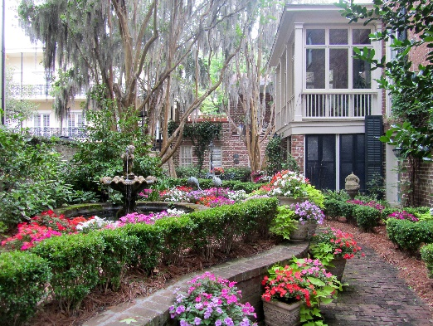
VISIT SAVANNAH’S HISTORIC DISTRICT & ENJOY A “HIDDEN GARDENS TOUR & TEA”
The Garden Club at Palm Coast has organized a trip to Savannah, GA in spring, 2019. In addition to visiting one of the south’s most beautiful and historic cities, we will tour seven hidden gardens and enjoy afternoon tea at one location. This “Hidden Gardens Tour & Tea” is an annual event held by The Garden Club of Savannah, a fellow member of NGC (National Garden Clubs).

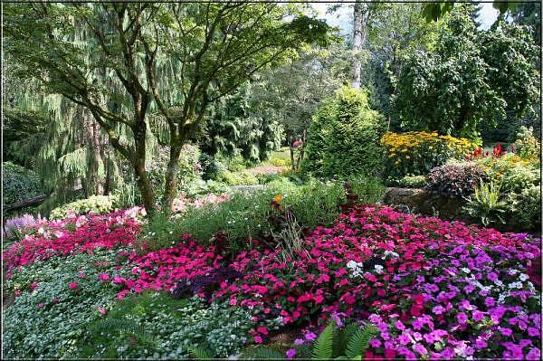
This is a two-day trip! Friday, April 26-Saturday, April 27, 2019
Departs: Palm Coast, April 26th at 7:30 AM (Target Parking Lot-RT 100)
Returns: April 27th at approximately 7:00 PM
In 1975, The Garden Club of Savannah elected to host a spring tour of gardens which is now limited to those properties north of Gwinnett Street. In April, 2019 the club will celebrate the 44th anniversary of their only fundraiser. Funds from this event are donated to numerous organizations throughout Savannah to help keep the city beautiful.
Excursion details on this 2 day trip include the following:
- Motor Coach Transportation (from Palm Coast)
- Hotel Accommodations (SpringHill Inn & Suites-Downtown).Free Breakfast & Wi-Fi
- 2 Day Ticket for the “Hidden Gardens Tour & Tea”
- Trolley Tour of Historic District
Pricing is per person. You will need to pay in advance for the Hidden Gardens Tour Ticket, Trolley Tour Ticket and the Motor Coach Transportation. Total advance payment is $145.00, due by December 1,2018.
Hotel Reservations will be made for you at a group rate of $226.35 (includes tax). This reservation is based on double occupancy. (2 persons per room). If you are sharing a room, the hotel will be happy to split that charge at time of checkout. Each person may use their own credit card. We will need your credit card number in order to hold your room. If you are traveling with a friend, it is only necessary for one to hold the hotel reservation. Sharing the cost will take place at checkout.
Pricing does not include breakfast, lunch or dinner.
Sign- up sheet: Complete page 2 and return before December 1, 2018. Space is limited to 50 persons and is reserved on a first come/first served basis. The Motor Coach and Garden Tour Tickets must be paid in December. Please make checks payable to The Garden Club at Palm Coast.

VISIT SAVANNAH’S HISTORIC DISTRICT &
ENJOY A HIDDEN GARDENS TOUR & TEA
SIGN UP SHEET (Couples only need one sheet - Individuals, a sheet for each person)
Please print clearly and return to: Kathleen Terlizzo, 1 Clearview Ct N, Palm Coast, FL 32137.
If you have any questions or concerns, feel free to call 386-864-7460 or e-mail kterlizzo@cfl.rr.com
NAME (S) _____________________________________________________________________
ADDRESS_________________________________________________________________________
City________________________________ STATE_________________________ZIP____________
PHONE (H) __________________________________ _____________________________
E-MAIL __________________________________________________________________
AMOUNT ENCLOSED _________ ($145 per person) CHECK # _______________(payable to: GC at Palm Coast)
CREDIT CARD INFO
TYPE OF CARD (CIRCLE ONE) VISA MASTER CARD
NAME (AS IT APPEARS ON CARD) __________________________________________________
CARD # ______________________________________________________________
EXP. DATE __________ YEAR ____________ SECURITY CODE ____________________
______USE CREDIT CARD INFO FOR BOTH ADVANCE PAYMENT AND HOTEL RESERVATION
______ USE CREDIT CARD INFO ONLY TO SECURE HOTEL RESERVATION
I WILL BE SHARING A ROOM WITH
NAME ______________________________________________
WHO WILL SECURE THE HOTEL RESERVATION?
______ I WILL
_____ MY ROOM MATE WILL (SEE THE SIGN UP SHEET FOR CREDIT CARD INFO)

