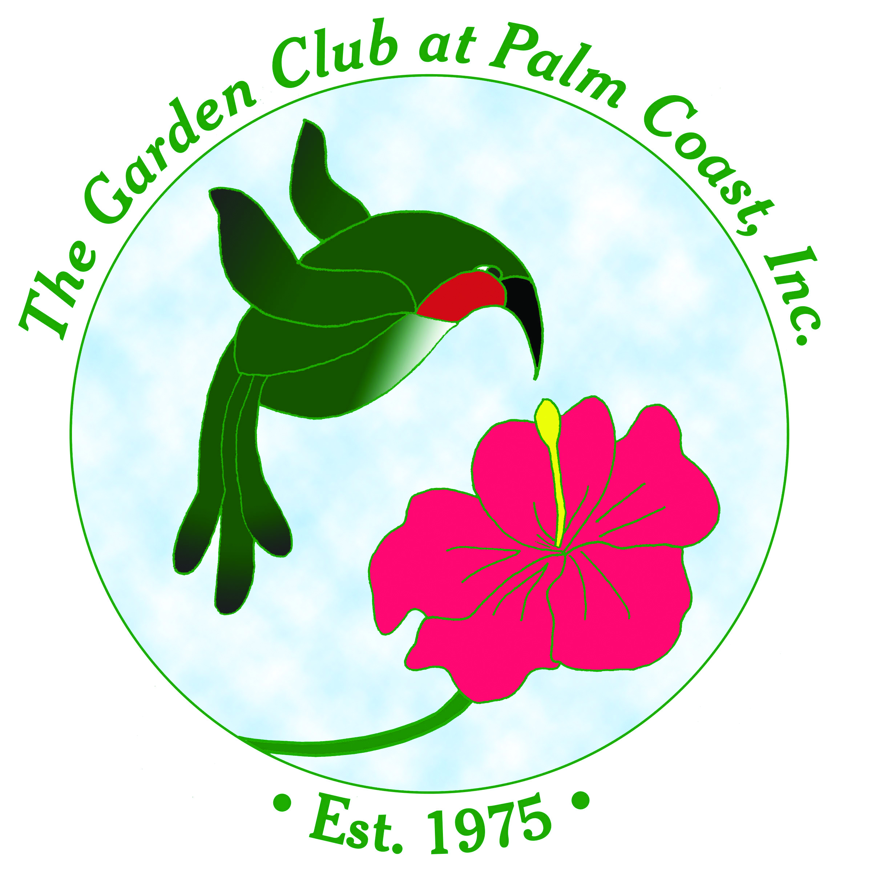
Salt Tolerant Plants For Flagler & Volusia County
Compiled by The Propagation Guild of
The Garden Club at Palm Coast

High Salt Tolerant
Grasses

Shizachyrium scoparium | Coastal Bluestem
Spartina patens (N) | Marshhay Cordgrass
Muhlenbergia capillaris (N) | Muhly Grass
Juncus roemerianus (N) | Needle Rush
Panicum amarum | Bitter Panic Grass
Distichlis spicata (N) | Salt Grass
Spartina bakeri (N) | Sand Cordgrass
Cladium jamaicense (N) | Saw-grass
Uniola paniculata (N) | Sea Oats
Sporobolus virginicus | Seashore Dropseed
Paspalum vaginatum (N) | Seashore Paspalum
Schoenoplectus pungens (N) | Three-square Bulrush
Groundcovers

Iva imbricata | Beach Elder
Hymenocallis latifolia | Beach Spider Lily
Gaillardia pulchella (N) | Blanket Flower
Trachelospermum jasminioides | Confederate Jasmine
Ficus pumila | Creeping Fig
Dichondra caroliniensis | Dichondra
Helianthus debilis (N) | Dune Daisy/Beach Sunflower
Hedera helix | English Ivy
Licania michauxii (N) | Gopher Apple
Carpobrotus edulis | Hottentot Fig/Ice Plant
Lirope spicata | Liriope
Portulaca spp. | Purslane
Borrichia frutescens | Sea Oxeye
Parthenocissus quinquefolia (N) | Virginia Creeper
Lantana montevidensis | Weeping Lantana
Palms

Sabal palmetto (N) | Cabbage Palm
Phoenix dactylifera (N) | Date Palm
Chamaerops humilis | European Palm
Serenoa repens (N) | Green Saw Palmetto
Rhapis excelsa | Lady Palm
Butia capitata | Pindo Palm
Arecastrum romanzoffianum | Queen Palm
Serenoa repens 'silver' (N) | Silver Saw Palmetto
Washingtonia spp. | Washingtonian Palm
Trachycarpus fortunei | Windmill Palm
Shrubs

Yucca smalliana | Adam’s Needle
Conocarpus erectus (N) | Buttonwood
Lycium carolinianum (N) | Christmas Berry
Zamia pumila (N) | Coontie
Euphorbia milii | Crown-of-thorns
Aralia spinosa (N) | Devil’s Walking Stick
Helianthus debilis (N) | East Coast Dune Sunflower
Citharexylum spinosum (N) | Fiddlewood
Forestiera segregata (N) | Florida privet
Iva frutescens (N) | Marsh Elder
Carissa grandiflora | Natal Plum
Sophora tomentosa (N) | Necklace Pod
Nerium oleander | Oleander
Pittosporum tobira | Pittosporum
Opuntia humifusa (N) | Prickly-Pear Cactus
Batis maritima (N) | Saltwort
Borrichia frutescens (N) | Sea-oxeye Daisy
Conradina grandiflora (N) | Scrub Mint
Coccoloba uvifera (N) | Sea Grape
Baccharis halimifolia (N) | Sea-Myrtle / Groundseltree
Iva imbricata (N) | Seaside/Beach Elder
Ilex vomitoria 'Schillings Dwarf' (N) | Schilling’s Dwarf Yaupon Holly
Myrcianthes fragrans (N) | Simpson's Stopper
Chiococca alba (N) | Snowberry
Yucca aloifolia (N) | Spanish Bayonet
Sideroxylon tenax (N) | Tough Bumelia
Dodonia viscosa (N) | Varnish Leaf
Myrica cerifera (N) | Wax Myrtle
Ilex vomitoria (N) | Yaupon Holly
Ferns
Acrostichum danaeifolium (N) | Giant Leather Fern
Trees

Taxodium distichum (N) | Bald Cypress
Persea borbonia (N) | Florida Red Bay
Cyrilla racemiflora (N) | Leatherwood
Quercus virginiana (N) | Live Oak
Juniperus virginiana (N) | Red Cedar
Sapindus saponaria (N | Soapberry
Persea palustris (N) | Swamp Red Bay
Acacia farnesiana | Sweet Acacia
Myrica cerifera (N) | Wax Myrtle
Vines

Hedera canariensis | Algerian Ivy
Ipomoea imperati | Beach Morning Glory
Bougainvillea spp. | Bougainvillea
Tecomaria capensis | Cape Honeysuckle
Ipomoea pes-caprae (N) | Railroad Vine
Wildflowers

Verbena maritima (N) | Beach Verbena
Gallardia pulchella (N) | Blanket-flower
Trichostema dichotomum (N) | Blue Curls
Cassia chapmanii (N) | Chapman's Senna
Cakile lanceolata (N) | Coastal Searocket
Monarda punctata (N) | Dotted Horsemint/Spotted Beebalm
Opuntia stricta (N) | Erect Prickly Pear Cactus
Phyla nodiflora (N) | Frogfruit
Lantana depressa (N) | Lantana - Florida
Heliotropium angiospermum (N) | Scorpion's-Tail
Sesuvium portulacastrum (N) | Sea-purslane
Solidago sempervirens (N) | Seaside Goldenrod
Bidens alba (N) | Spanish Needles
Hymenocallis latifolia (N) | Spider Lily
Ipomopsis rubra (N) | Standing Cypress
Solidago odora (N) | Sweet Goldenrod
Solidago stricta (N) | Wand Goldenrod
Flaveria linearis (N) | Yellow-top
Medium Salt Tolerance
Grasses

Eragrostis elliottii (N) | Elliott’s Lovegrass
Tripsacum dactyloides (N) | Fakahatchee Grass
Tripsacum floridanum (N) | Fakahatchee Grass - Dwarf
Sorghastrum secundum (N) | Lopsided Indiangrass
Juncus effusus (N) | Soft Rush
Groundcovers

Alternanthera spp. | Blood Leaf
Senecio confusus | Mexican Flame Vine
Mimosa strigulosa (N) | Mimosa/Sensitive Plant
Setcrease pallida | Purple Queen
Zebrina pendula | Wandering Jew
Bacopa monnieri (N) | Water Hyssop
Palms

Sabal minor (N) | Blue Stem Palmetto
Phoenix canariensis (N) | Canary Island Date Palm
Sabal etonia (N) | Scrub Palmetto
Shrubs

Vaccinium corymbosum x darrowii (N) | Blueberry - Highbush
Vaccinium mysinites (N) | Blueberry - Shiny/Lowbush
Eranthemum pulchellum | Blue Sage
Callistemon rigidus | Bottlebrush
Vitex agnus-castus | Chaste Tree
Erythrina herbacea (N) | Coral Bean/Cherokee Bean
Oenothera laciniata (N) | Cutleaf Evening Primrose
Pedilanthus tithymaloides | Devil’s Backbone
Ilex glabra 'Compacta' (N) | Dwarf Gallberry
Amorpha fruticosa (N) | False Indigo
Fatsia japonica | Fatsia
Agarista populifolia (N) | Fetterbush/Pipestem
Hamelia patens (N) | Firebush
Pyracantha coccinea | Fire-thorn
Ilex glabra (N) | Gallberry
Mahonia spp. | Grape Hollies
Cereus peruvianus | Hedge Cactus
Rhaphiolepis indica | Indian Hawthorn
Ixora coccinea | Ixora
Thevetia peruviana | Lucky Nut
Ardisia escallonioides (N) | Marlberry
Cestrum nocturnum | Night Cestrum
Pseuderanthumum atropupureum | Pseuderanthemum
Sesbania punicea | Rattlebox
Homalocladium platycladum | Ribbon Bush
Rhodendron indicum | Satsuki Azalea
Lyonia lucida (N) | Shiny Lyonia/Fetterbush
Psychotria nervosa (N) | Shiny-leaf Wild Coffee
Clethra alnifolia (N) | Summersweet
Vitex trifolia ‘Variegata’ | Vitex
Psychotria nervosa (N) | Wild Coffee
Ferns
Psilotum nudum (N) | Whisk Fern
Trees

Ilex opaca (N) | American Holly
Prunus serotina (N) | Black Cherry
Erythrina spp. | Coral Tree
Prunus caroliniana (N) | Cherry Laurel
Ilex cassine (N) | Dahoon Holly
Zanthozylum clava-herculis (N) | Hercule's Club / Toothache Tree
Parkinsonia aculeata | Jerusalem Thorn
Quercus laurifolia (N) | Laurel Oak
Eriobotrya japonica | Loquat
Quercus myrtifolia (N) | Myrtle Oak
Taxodium ascendens (N) | Pond Cypress
Quercus geminata (N) | Sand Live Oak
Pinus clausa (N) | Sand Pine
Persea humilis (N) | Silk Bay
Pinus elliottii (N) | Slash Pine
Magnolia grandiflora (N) | Southern Magnolia
Juniperus silicicola | Southern Red Cedar
Magnolia virginiana (N) | Sweet Bay
Liquidambar styraciflua (N) | Sweet Gum
Vines

Gelsemium sempervirens (N) | Carolina Jasmine
Lonicera sempervirens (N) | Coral Honeysuckle
Bignonia capreolata | Crossvine
Hedera canariensis | Creeping Fig
Smilax auriculata | Earleaf Catbrier
Ipomoea sagittata (N) | Glades Morning Glory
Vitis rotundifolia (N) | Muscadine
Mandevillea splendens | Pink Allamanda
Passiflora suberosa (N) | Passion Flower - Corkystem
Campsis radicans (N) | Trumpet Creeper
Wildflowers

Rudbeckia hirta (N) | Black Eyed Susan
Asclepias tuberosa (N) | Butterfly Weed
Ruellia caroliniensis (N) | Carolina Petunia
Glandularia maritima (N) | Coastal Vervain
Chrysopsis gossypina (N) | Hairy Golden Aster
Erigeron quercifolius (N) | Oak-leaf Fleabane
Chamaecrista fasciculata (N) | Partridge pea
Opuntia humifusa (N) | Prickly Pear Cactus
Cirsium horridulum (N) | Purple Thistle
Melanthera nivea (N) | Snow Squarestem
Crinum americanum (N) | Swamp Lily
Cnisoscolus stimulosus (N) | Tread-Softly
Neptunia pubescens (N) | Tropical Neptunia
Salvia coccinea (N) | Tropical Sage
Vernonia gigantea (N) | Veronia/Tall Ironweed
Physalis walteri (N) | Walter’s Groundcherry
Verbesina virginica (N) | White Crownbeard / Frostweed
Plumbago scandens (N) | Wild Plumbago
Teucrium canadense (N) | Wood-sage
Achillea millefolium (N) | Yarrow

Low Salt Tolerance
Grasses

Eragrostis spectabilis (N) | Purple Lovegrass
Shrubs

Illicium floridanum (N) | Anise - Red
Illicium parviflorum (N) | Anise - Yellow
Rhododendron austrinum (N) | Azalea - Florida Flame
Rhododendron canescens (N) | Azalea - Florida Pinxter
Callicarpa americana (N) | Beauty Berry
Buddleia officinalis | Butterfly Bush
Tabernaemontana divaricata | Cape Jasmine
Holmskioldiana sanguinea | Chinese Hat Plant
Asimina triloba (N) | Common Pawpaw
Acalypha wilkesiana | Copper Leaf
Lagerstroemia indica | Crape Myrtle
Codiaeum variegatum | Croton
Cuphea hyssopifolia | Cuphea
Hibiscus rosa-sinensis | Hibiscus
Ligustrum japonicum | Japanese Privet
Acca sellowiana | Pineapple Guava
Hydrangea quercifolia (N) | Oakleaf hydrangea
Viburnum nudum (N) | Possum Haw / Appalachia Tea
Lyonia ferruginea (N) | Rusty Lyonia
Plumbago auriculata | Plumbago
Euphorbia pulcherrima | Poinsettia
Tibouchina urvilleana | Princess Flower
Tetrapanax papyriferus | Rice-paper Plant
Sanchezia speciosa | Sanchezia
Breynia nivosa | Snow Bush
Calycanthus floridus (N) | Sweet Shrub/Allspice
Galphimia glauca | Thryallis
Itea virginica (N) | Virginia Sweetspire/Willow
Viburnum obovatum (N) | Walter's Viburnum
Callicarpa americana 'lactea' (N) | White Beauty Berry
Baptisia lactea (N) | Wild White Indigo
Tecoma stans | Yellow Elder
Trees

Ilex opaca (N) | American Holly
Prunus angustifolia (N) | Chickesaw Plum
Ilex cassine (N) | Dahoon Holly
Ilex x. attenuata (N) | East Palatka Holly
Celtis laevigata (N) | Hackberry
Gordonia lasianthus (N) | Loblolly Bay
Cercis canadensis (N) | Red Bud
Ilex vomitoria 'Weeping' (N) | Weeping Yaupon
Vines

Allamanda spp. | Allamanda
Gelsemium spp. (N) | Carolina/Yellow Jessamine
Solandra guttata | Chalice Vine
Jasminum multiflorum | Downy Jasmine
Clytostoma callistegioides | Painted Trumpet
Jasminum nitidum | Star Jasmine
Campsis radicans (N) | Trumpet Vine
Wildflowers

Liatris spp. (N) | Blazing Star
Eryngium yuccafolium (N) | Button Snakeroot / Rattlesnake Master
Lobelia cardinalis (N ) | Cardinal Flower
Iris virginica (N) | Iris - Blue Flag
Iris hexagona (N) | Iris - Prairie
Salvia lyrata (N) | Lyre-Leaved Sage
Helianthus angustifolius (N) | Narrow Leaf/Swamp Sunflower
Carphephorus corymbosis (N) | Paintbrush - Florida
Hibiscus grandiflorus (N) | Swamp hibiscus
Canna flaccida (N) | Yellow canna

_________________________________________________________________________________________
(N) = Native Plant
High Salt Tolerant Plants: Highly resistant to salt drift and can be used in exposed environments.
Moderately Salt-Tolerant Plants: Some salt spray but grow best when protected by buildings, fences, or plantings of more salt-tolerant species.
Slightly Salt-Tolerant Plants: Poor tolerance and should be always used well back of exposed areas and be protected by buildings, fences, or plantings of more salt-tolerant species.

