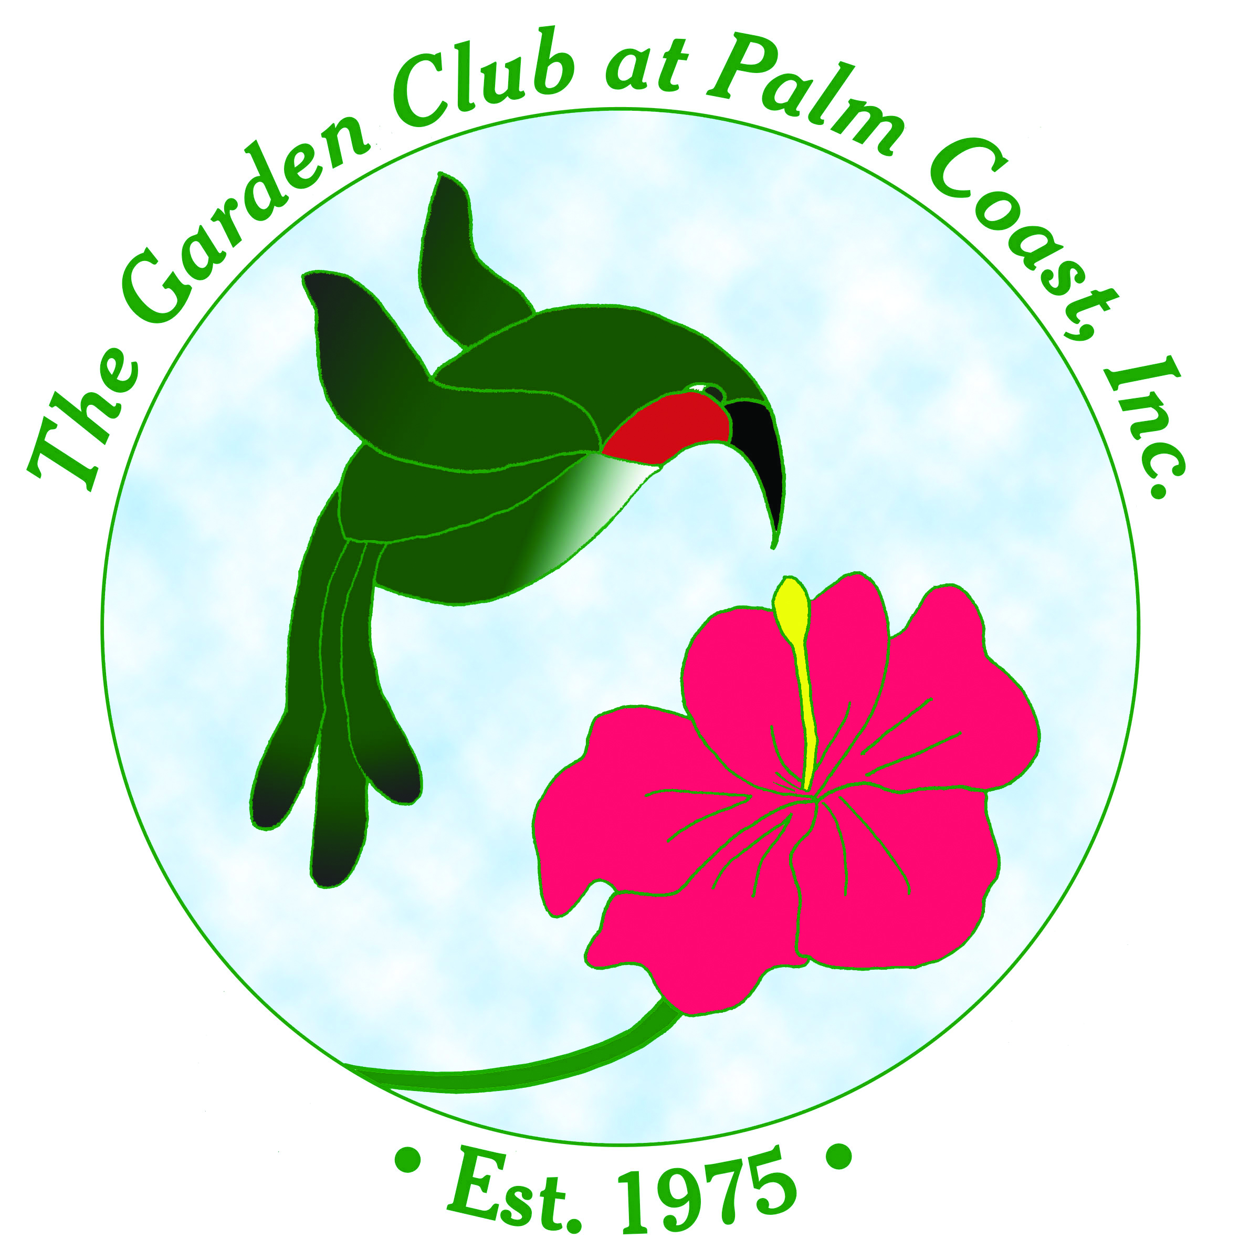
Hummingbird Plants for Flagler County
Compiled by the Propagation Guild of
The Garden Club at Palm Coast

Trees and shrubs
Acca sellowiana | Pineapple Guava
Aesculus pavia | Red Buckeye | Native
Buddleia alternifolia | Butterfly Bush
Cephalanthus occidentalis | Buttonbush
Callistemon spp. | Bottlebrush
Crataegus spp. | Haw
Duranta repens | Golden Dewdrop
Hamelia patens | Firebush | Native
Hibiscus coccineus | Red Star Hibiscus | Native
Iochroma cyaneum | Violet Tubeflower
Jatropha integerrima | Jatropha
Lantana spp. | Lantana | Native
Liriodendron tulipifera | Tulip Tree
Malvaviscus spp. | Turk’s Cap
Mimosa julibrissin | Persian Silk Tree
Odontonema stricta | Firespike
Plumbago scandens | Wild Plumbago | Native
Rhododendron spp. | Wild Azalea | Native
Russelia equisetiformis | Firecracker Plant

Annuals and Perennials
Agastache spp. | Agastache
Antirrhinum spp. | Snapdragon
Aquilegia canadensis | Wild Columbine
Asclepias tuberosa | Butterfly Milkweed | Native
Aloe saponaria | Soap Aloe | Native
Calamintha coccinea | Red Basil | Native
Canna flacida | Florida Canna | Native
Cleome spp. | Spiderflower
Conradina canescens | Wild Rosemary
Coreopsis spp. | Tickseed | Native
Cuphea ignea | Cigar Flower
Dianthus barbatus | Sweet William
Dychoriste oblongifolia | Twinflower | Native
Echinacea purpurea | Coneflower | Native
Erythrina herbacea | Coral Bean | Native
Gaillardia pulchella | Blanket Flower | Native
Gloxinia sylvatica | Bolivian Sunset
Justicia brandegeana | Shrimp Plant
Kalanchoe blossfeldiana | Kalanchoe
Leonotis leonurus | Lion’s Tail
Liatris spp. | Liatris | Native
Lobelia cardinalis | Cardinal Flower | Native
Mirabilis jalapa | Four O’Clock
Monarda punctata | Horsemint/Beebalm | Native
Nicotiana spp. | Flowering tobacco
Penstemon australis | Pink Beardtongue | Native
Pentas lanceolata | Tall Red Pentas
Phlox spp. | Phlox
Physostegia spp. | Obedient Plant | Native
Portulaca pilosa | Purslane | Native
Rudbeckia hirta | Black Eyed Susan | Native
Ruellia caroliniana | Wild Petunia | Native
Salvia azurea | Blue Sage | Native
Salvia coccinea | Texas Sage
Salvia lyrata | Lyre-Leaved Sage
Scutellaria integrifolia | Skullcap | NaTive
Stachytarpheta jamaicensis | Porterweed | Native
Teucrium canadense | Germander/Wood Sage | Native
Tithonia rotundifolia | Mexican Sunflower
Verbena tampensis | Tampa Verbena | Native
Veronica spp. | Speedwell
Yucca filamentosa | Yucca | Native

Vines
Bignonia capreolata | Crossvine | Native
Campsis radicans | Trumpet Creeper | Native
Ipomoea coccinea | Scarlet Morning Glory | Native
Ipomoea pes-caprae | Railroad Vine | Native
Ipomoea quamoclit | Cypress Vine | Native
Ipomopsis rubra | Standing Cypress | Native
Lonicera sempervirens | Coral Honeysuckle | Native

